

Tenancy Termination Form - Tenant Deceased

Please complete this form if you are the next of kin or person/s acting on behalf of a Cheltenham Borough homes tenant who has died.

I (name) ………………………………………………………………………………………………………..
of (address) ……………………………………………………………………………………………………
…………………………………………………………………………………………………………………..
give four weeks notice to terminate the tenancy at ……………………………………………………….
…………………………………………………………………………………………………………………..
ending on Sunday …………………………………………………………………………………………….

I am acting on behalf of the tenant (name) ……………………………………………………………….
who died on …………….. …………………. (date).
I enclose a copy of the Death Certificate.
or
I have not enclose a copy of the Death Certificate Reason………………………………………
I understand that a full set of keys should be returned to Cheltenham Borough Homes, to include keys for sheds and gates, any communal area keys and communal door fobs

Clearing The Property
I understand that I must clear all items from the property, loft and any external stores/ sheds. This includes all furniture, floor coverings (excluding vinyl in the bathroom and kitchen), window blinds and curtains, cooker, kitchen white goods, personal items and rubbish.

I will secure the wheelie bin/recycling boxes in a secure garden, shed or inside the property and understand that there may be a recharge if the wheelie bin is missing and has to be replaced.

I understand that I need to return the property in a clean and clear condition and with no damage except that due to fair wear and tear. Failure to do this will result in the estate being recharged for the cost of Cheltenham Borough Homes carrying out the necessary clearance, cleaning or repair work.

Bereavement Rent Reduction During Notice Period
I understand that if I return the property to Cheltenham Borough Homes in a clean condition, clear of all items (as outlined in the paragraph above) and free from tenant damage then Cheltenham Borough Homes will not charge the estate of the deceased for the final 2 weeks of the 4 week notice period.

I / We intend to return the property to Cheltenham Borough Homes in a condition to qualify for the Bereavement Rent Reduction. Yes / No (Delete as Appropriate)

P.T.O

Signed . . . . . . . . . . . . . . . . . . . . . . . .
Date . . . . . . . . . . . . . . . . . . . . . . . . . . . . . . . . . . .
Relationship to tenant . . . . . . . . . . . . . . . . . . . . . . . . . . . . . . . . . . . . . . . . . . . . . . . . . . . .
My contact telephone number is . . . . . . . . . . . . . . . . . . . . . . . . . . . . . . . . . . . . . . . . . . . .

Property Details
If known, could you please provide Cheltenham Borough Homes with the following details:-
Name of Current Gas Supplier (e.g. British Gas): …………………………………………………………………..
Name of Current Electric Supplier: …………………………………………………………………………………….

Details Of Any Disabled Adaptations to the Property (e.g. ramped access to the property, level access walk in shower, adaptations to the property for wheelchair use): .……………………………………………………………………………………………………………………………..………………………………………………………………………………………………………………………………
If you have a shed please advise us of the number or position of the shed ………………………………………………………………………………………………………………………………

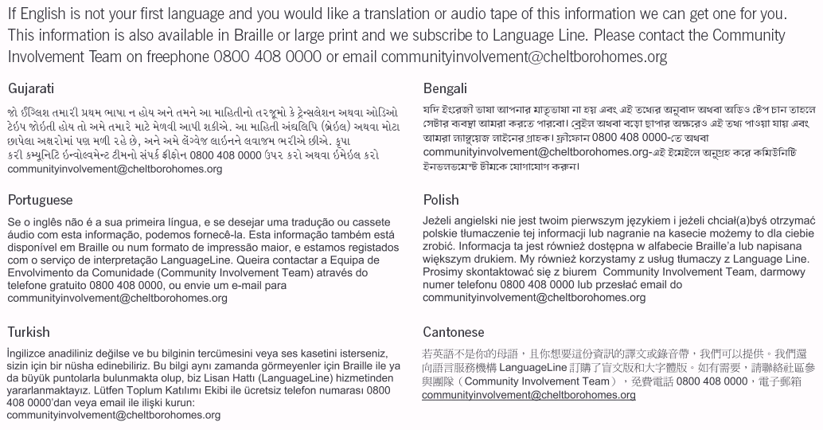

Please return this form to:

Cheltenham Borough Homes
Empty Homes Team
Oakley Community Resource Centre
113A Clyde Crescent
Cheltenham
GL52 5QL

Freephone 0800 408 0000
Fax 01242 264175

For office use only:
Termination Date . . . . . . . . . . . . . .
Termination Code . . . . . . . . . . . . .
Area Code . . . . . . . . . . . . . . . . . . .
Property Type . . . . . . . . . . . . . . . .
Rent Balance . . . . . . . . . . . . . . . . .

